**LAB REPORT NO 01**



**CSE-403L**

**Data Base Management System Lab**

**Submitted By: Naveed Ahmad**

**Registration No: 22PWCSE2165**

**Section: B**

“On my honor , as student of University of Engineering and Technology, I have neither given nor received unauthorized assistance on this academic work”

Signature: ________

March 6, 2025

**Submitted To: Engr. Sumayyea Salahuddin**

Department of Computer Systems Engineering University of Engineering and Technology

**Homework 1:** Forms play critical role in taking data to and from users. To enhance this ability, design three different types of forms using HTML Form. (Note: Don’t use CSS or Bootstrap. Only HTML.) Example forms can be registration form, contact form, student feedback form, etc. Provide short description and code of each form with its respective output in your lab report.

**FORM 1:**

**Code:**

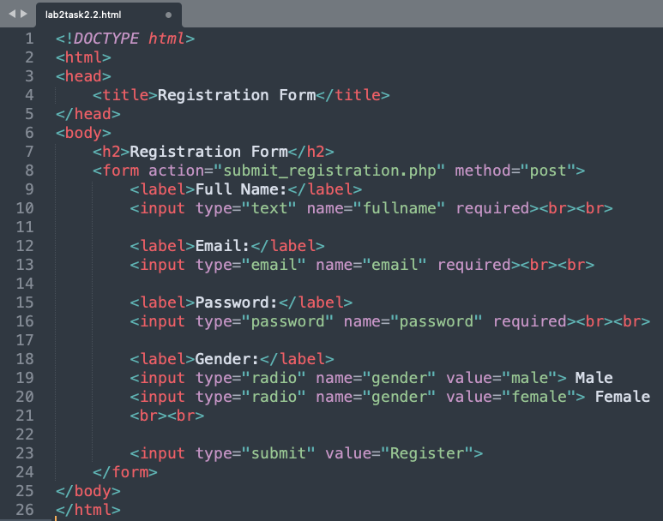

**Output:**

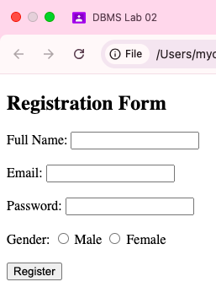

**FORM 2:**

**Code:**

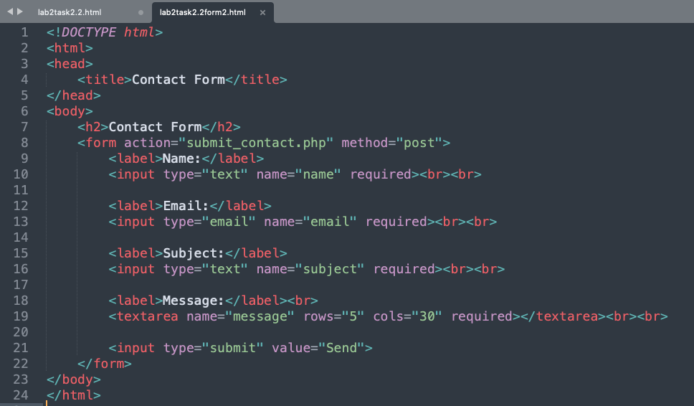

**Output:**

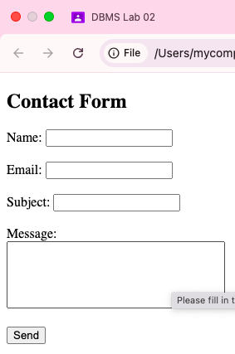

**FORM 3:**

**Code:**

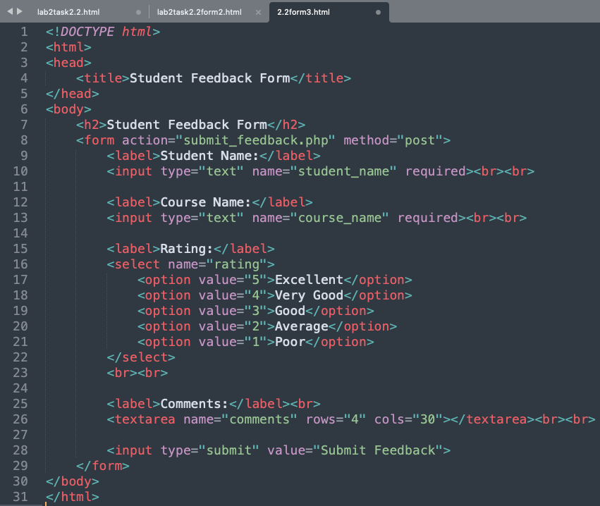

**Output:**

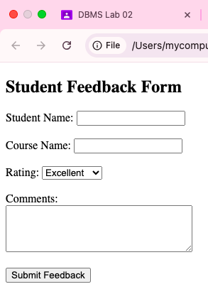

**Homework 2:** There are many new features available in HTML 5. Pick at least five features that are not covered in this lab and introduce its usage through detailed examples and description. These features include figure, audio, video, svg, regular expressions, Geolocation, canvas, article, section, header, footer, drag & drop, form validation, and web sockets. Provide short description and code of each feature with its respective output in your lab report.

**1. <figure> and <figcaption> (Semantic Image Representation)**

The <figure> element is used to group media elements like images, illustrations, or code snippets along with a caption using <figcaption>.

Code:

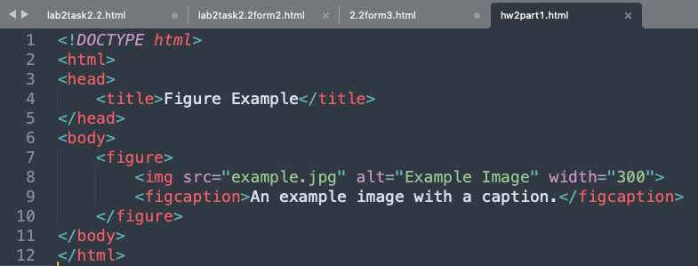

Output:

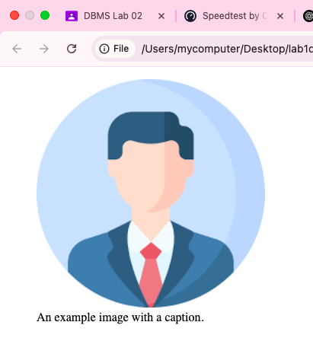

**2. <audio> (Embedding Audio)**

The <audio> tag allows embedding audio files with playback controls.

Code:

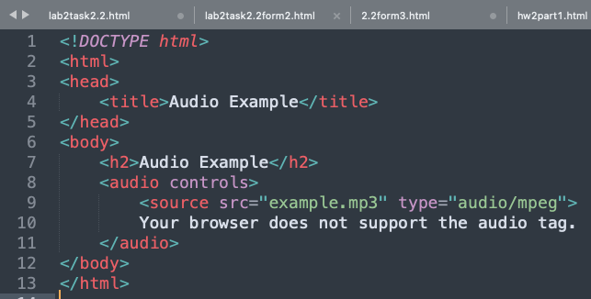

Output:

**3. <video> (Embedding Video)**

The <video> tag allows embedding videos with custom controls.

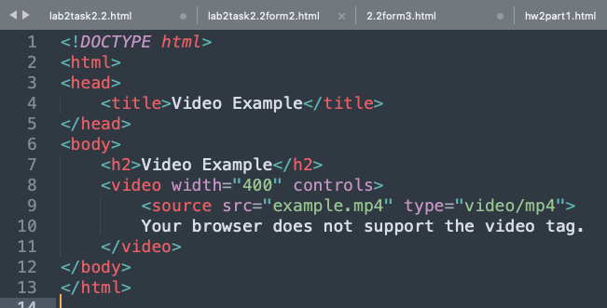

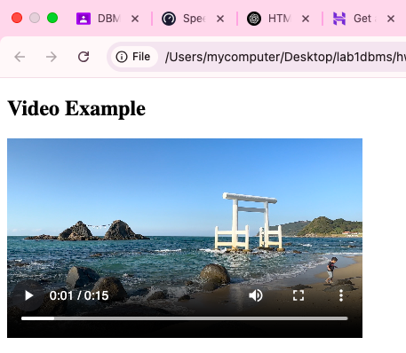

**4. Form Validation (required, pattern)**

HTML5 provides built-in form validation without JavaScript.

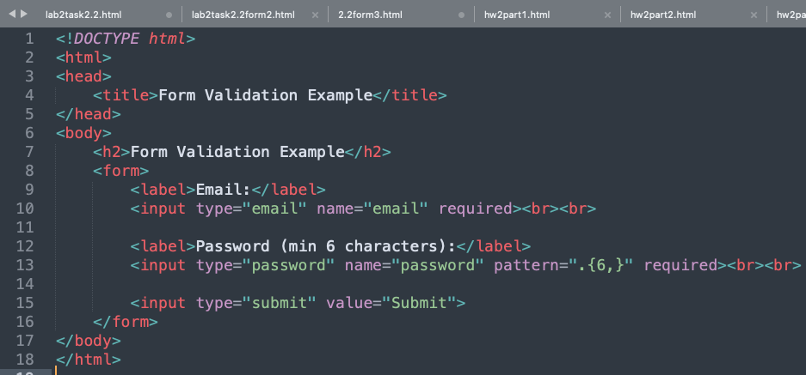

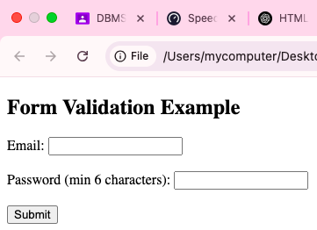

**5. <section> (Grouping Content)**

The <section> tag is used to define thematic content sections within a webpage.

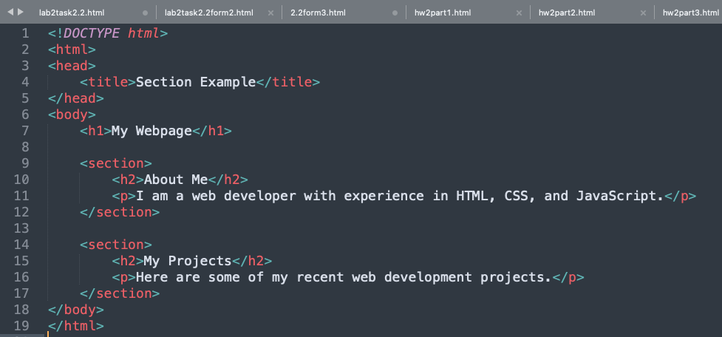

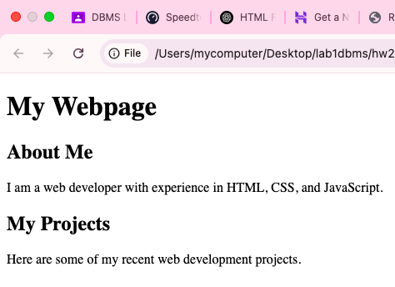

**Homework 3**: Design your CV using HTML 5 only and host it on 000webhost.com. (Note: You can host it on any other free hosting site of your choice.)

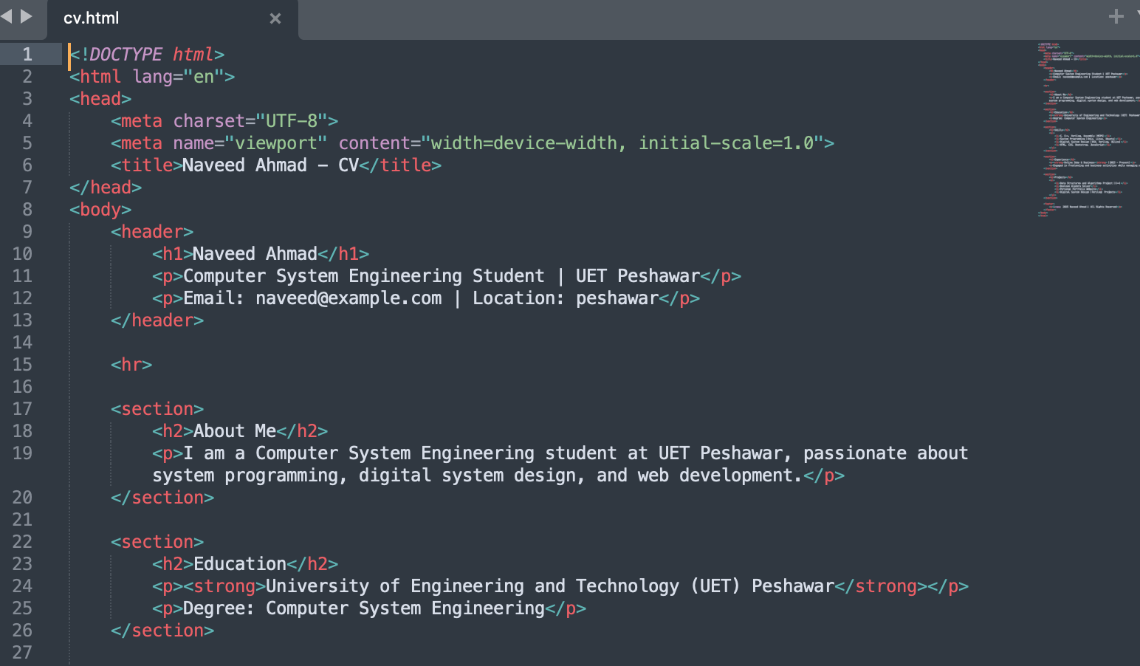

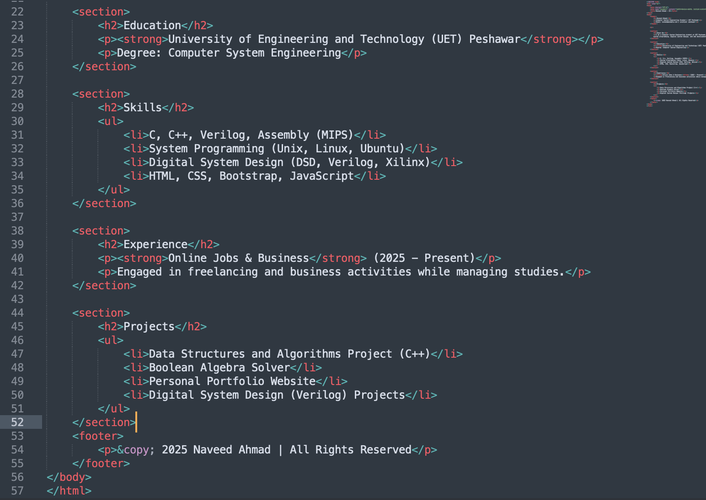

Output:

